4
Introducing Immaculate Records
This chapter covers:
- The sample application
- Ruby ORMs
- ActiveRecord

This whole part of the book is dedicated to bootstrapping you for the next part of the book where we’ll be actually using all these tools to build an application. Hopefully we now know more about the language and the .NET Framework than before we started this book. As we’ll be applying these technologies everything, what we are going to create should be a part of a larger concept. So for the rest of this book we’ll be employees of Immaculate Records in charge of developing a number of systems for this newly founded record label.
This chapter will also introduce some other concepts like using pure ruby components that were created by the ruby community; more specifically we’re going to look at some of the possibilities we have to perform data access. This should explain why we will be using the ActiveRecord implementation from the Ruby on Rails project.
But first things first, let’s talk a little about our job, more specifically which applications we will be building throughout the remaining parts of the book. Because we need to highlight mixing and matching the different technologies at our disposal we will do so by taking the most notable .NET technologies and combining that with some tools from the Ruby community. Whenever we need to create content for the web we will do so using the ASP.NET methodology and the Ruby On Rails way of doing things.
Because our record label is still in its early days we need a system to manage the artists, songs and albums. The application will be simple because the purpose is to demonstrate the underlying technologies. Let’s get started by looking at the high level design concepts that we’ll be applying to build the application.
4.1 Our solution explained
Our record label just started and we are starting to find some artists. This first section of the chapter is about making you familiar with what we’ll be doing throughout the next parts of the book.
So we work for the new cool kid on the block, a record label that promotes new artists, a place where dreams come true, yada yada yada … Yes sir, ,we’re a startup ! And you can be sure it’s going to be different for us. Obviously we’re going to use the techniques that all the other cool kids on the block are using. The applications we will be building are snapshot situations from taking the company from start-up to international player with its own stores. The applications we are going to build are also greatly simplified because it’s about tying all the technologies together. We will endeavor to use Ruby whenever we can, however there are a couple of places where we’re going to have to use C# or VB.NET. In this book we will use C# as statically typed language when we really need it.
4.1.1 The Framework
We will be trying to reuse as much as possible from the code we write. Our application will be structured as an MVC application although for WPF we will expand that pattern slightly to enable binding properly. One thing we will be able to reuse across applications is the model layer. In this chapter we’ll explore building such a model layer entirely with metaprogramming.
Apart from basing our application structure on the MVC pattern we will be developing it using Behavior Driven Development (BDD), which should introduce us to our first ruby specific gem. A gem is the ruby way of packaging libraries that can be used to extend your ruby install. The ruby gem we will be using to practice behavior driven development is RSpec. The idea behind BDD is that you specify how you want your application to behave and you write those down in specs that you then run with RSpec. It’s a lot like test driven development but the semantics are different to enforce something that is regarded as a better practice.
We will also be keeping a close eye on the code coverage for our project. Because our project is quite volatile as the business is expanding we would like to ensure that we have enough specs for the application and we want to know if there are sections in our code that need testing. For people that are familiar with Rails you will notice that the folder structure we’re using is very similar to a rails application. The structure of a rails application is good so we kept that convention for this book.
We will practice iterative development for building our applications. This means that the application keeps on growing and we want to be able to revert our database schema back and forth. For this we’ll be using the migrations from the ActiveRecord gem that belongs to Rails. We can probably reuse the models in a couple of our applications so it makes sense to me to keep those in a shared location, we’ll be using symbolic links for that. Figure 4.1 shows how the overall architecture will look once we’re through with the book.

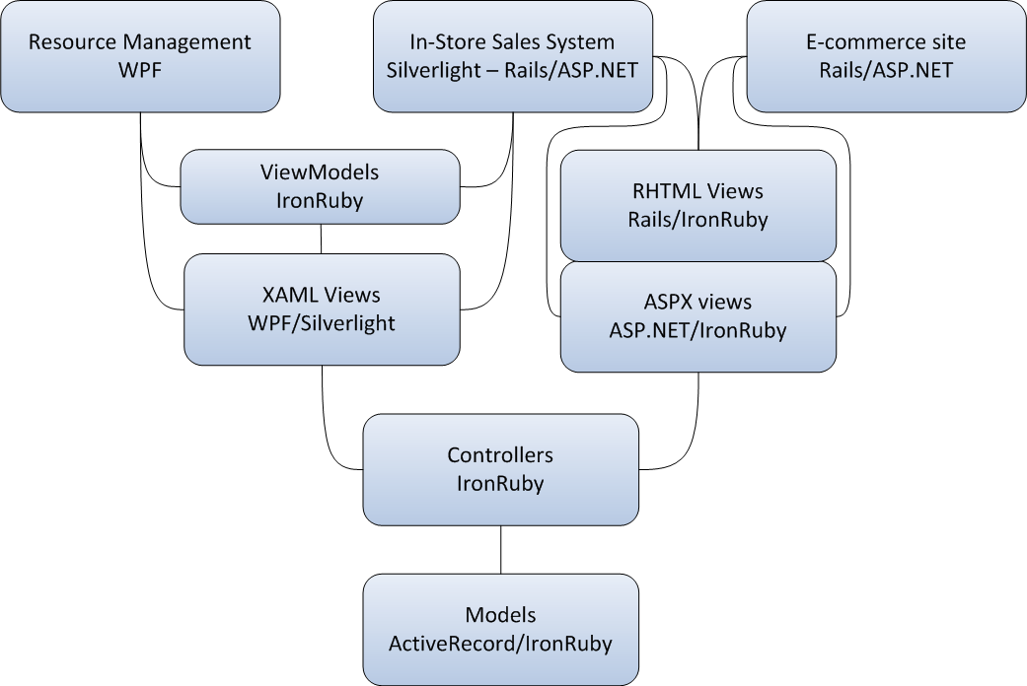
Figure 4.1: A high level overview of what the solution architecture could look like at the end of the book
In the figure the applications we’re going to build are on top of the drawing. And the lowest level we’ll be discussing is in the bottom of the drawing. Let’s talk a little about the Models layer and how that will play out in this chapter.
4.1.2 Persisting the state of the domain using Models
We will use sqlserver as our database server for the examples in this book. However you’ll only really need it for the examples we’ll be creating in this chapter. This chapter will show you a possible way for implementing a very simple model layer through metaprogramming. But later on in the book we’ll be relying on ActiveRecord from the Rails framework for our Object Relational mapping needs.
We’ve mentioned Rails before and it’s one of the reasons why many people are discovering Ruby as a language, it seemed appropriate to use that as our primary ORM throughout this book. There is plenty of information available about ActiveRecord on the internet and in other books, so we won’t cover usage in depth. To make sure that you will understand the queries we’ll create there will be a short literacy guide for ActiveRecord later in this chapter.
As mentioned before we’re going to be practicing iterative development, this includes that we will be generating our database schema as necessary. ActiveRecord provides a tool for that: Migrations. This means that we can generate a migration whenever we need to change something to the database. We can roll back migrations to correct mistakes we might have made and so forth. Migrations are a nice way of keeping track of your database schema and making it easy for other developers on your team to create the database they will need for working on your solution.
The next parts of this section will introduce the applications we’re going to build and which technologies we’ll be using when building those applications.
4.1.3 The resource management application
The first thing we’re going to need to build for our company is an application to manage resources like artists, studios, concerts, records … At this point this application will be used on the LAN only so we choose to create it as a WPF application. We chose WPF in favor of winforms because of the separation of layout from code through XAML. There are more advantages to using WPF like we’ve discussed in the previous chapter.

